DESIGN CONCEPT

One control room for every camera
Security Surveillance System for Hikvision NVRs and cameras: solution concept
Prepared for [Client name] · November 2026 · Companion to the presentation
About the screens in this document
Every screen shown is a design concept with illustrative data. It shows how the finished system is intended to look and work. Names, numbers, plates and camera images are samples. Nothing shown here is a running system; details will be shaped with your team before and during delivery.

Contents

1. About this document
This document accompanies the solution-concept presentation. It describes how the Security Surveillance System is intended to work for your sites, screen by screen, and lists the decisions and inputs needed from you to move into delivery.
The screens are design concepts. They make the ideas concrete so that your management, security and IT teams can react to them. The product name is a working title; the final name and branding will be agreed with you.

2. The challenge
The platform must unify your Hikvision NVRs and cameras into one control room and solve five problems:
- Geofencing: virtual boundaries that raise an alarm when crossed, on camera views and on GPS maps.
- Geotagging: every camera, event and clip tied to a place: site, building, zone and coordinates.
- Theft: loitering, object removal and after-hours activity spotted before losses grow.
- Security breaches: intrusion, tampering and after-hours access caught as they happen.
- Low light: clear night images, and warnings when a camera can no longer see.
Scale: 6 NVRs with 192 cameras today, growing to 20 NVRs and 640 cameras, with a mix of ColorVu, AcuSense and non-AI cameras. The design must work with the cameras you already own.

3. The solution at a glance
One platform sits between your devices and your people. It shows every camera on a managed video wall, raises alerts that matter using AI on every camera, knows where everything happens, and sends reports automatically.
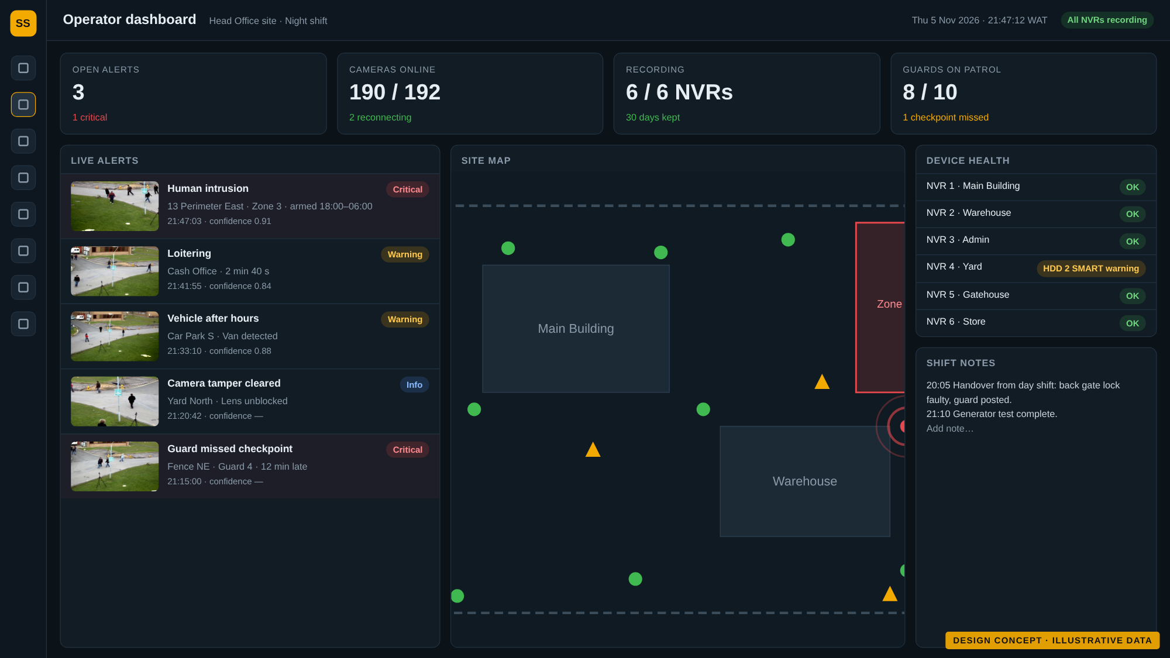
Figure 1. Operator dashboard. Design concept with illustrative data; not yet built.

4. The control room experience

4.1 A live wall for every NVR
Each NVR gets its own wall screen showing all 32 channels. With six NVRs that is six grid screens plus the spotlight screen. Grids use the cameras' low-bandwidth sub-streams so every tile stays smooth, and each camera is pulled from the NVR once and shared, so NVRs are never overloaded by viewers.
- A camera with an alert gets a red frame and label at once.
- A dropped camera reconnects by itself; the wall PC restarts a frozen screen.
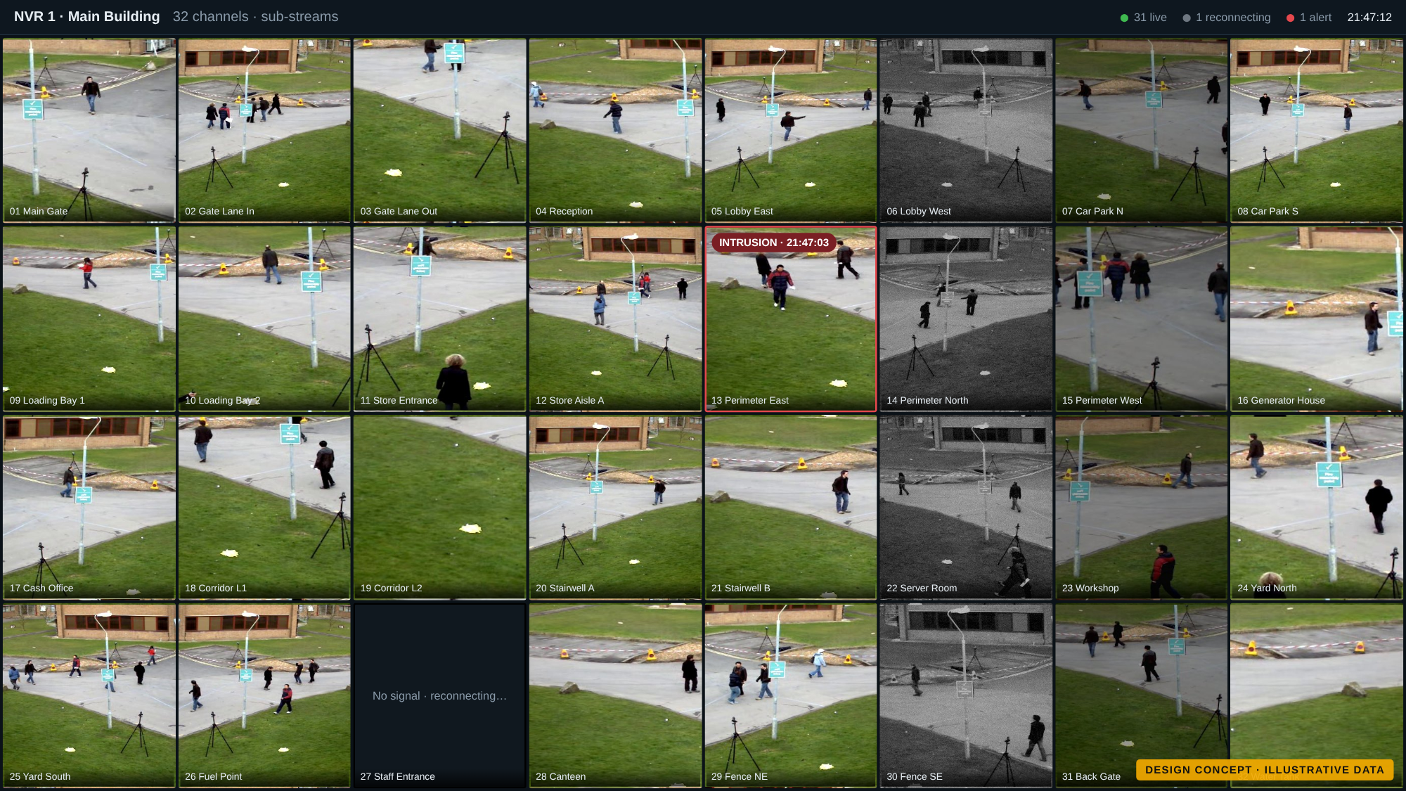
Figure 2. Wall screen for one NVR, 32 cameras. Design concept with illustrative data; not yet built.

4.2 Spotlight rotation
A separate screen shows four cameras at a time in full quality and moves to the next four every five seconds, looping through every camera. Group size and timing can be changed. Operators can pause or jump to a camera. A camera with an alert is pinned to this screen until someone acknowledges it. The next group is connected before each switch, so there are no black frames.
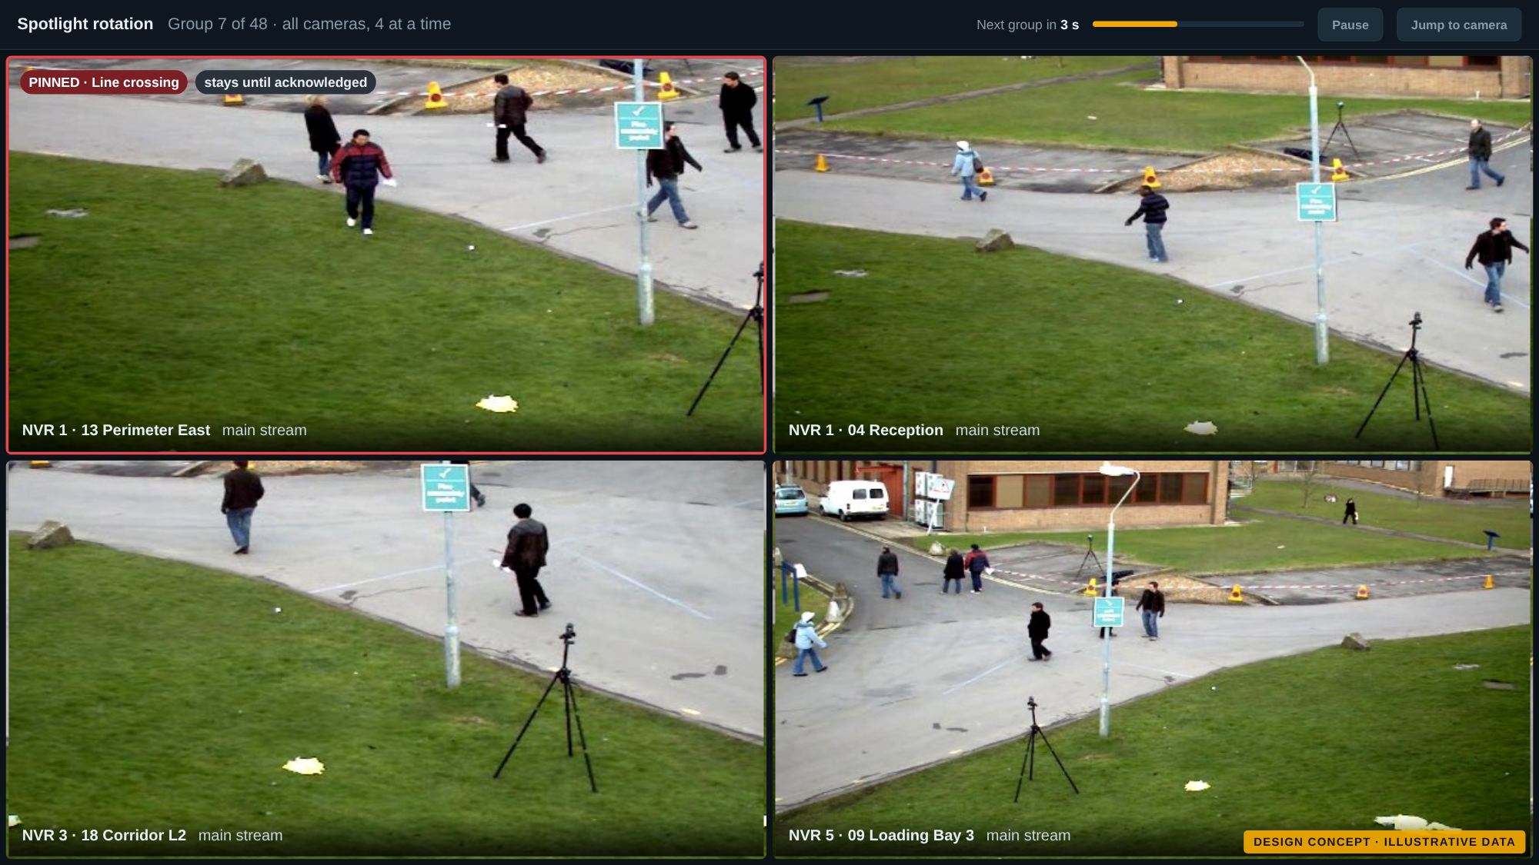
Figure 3. Spotlight rotation screen. Design concept with illustrative data; not yet built.

4.3 Operator dashboard
The operator's main screen combines the live alert feed (snapshot, camera, zone, time and confidence), the site map, device health and shift notes. Two clicks take the operator from any alert to its footage.

4.4 From alert to evidence
Every alert becomes an incident record with a full audit trail:
- Alert appears on the wall, on the dashboard and, if critical, on WhatsApp.
- Open the incident: snapshot, a clip from 10 seconds before to 20 seconds after, and nearby cameras.
- Act and record: acknowledge, assign, comment, escalate and close. Unacknowledged critical alerts escalate automatically. Evidence is copied from the NVR so it outlives the 30-day recording window, and exports carry a checksum.
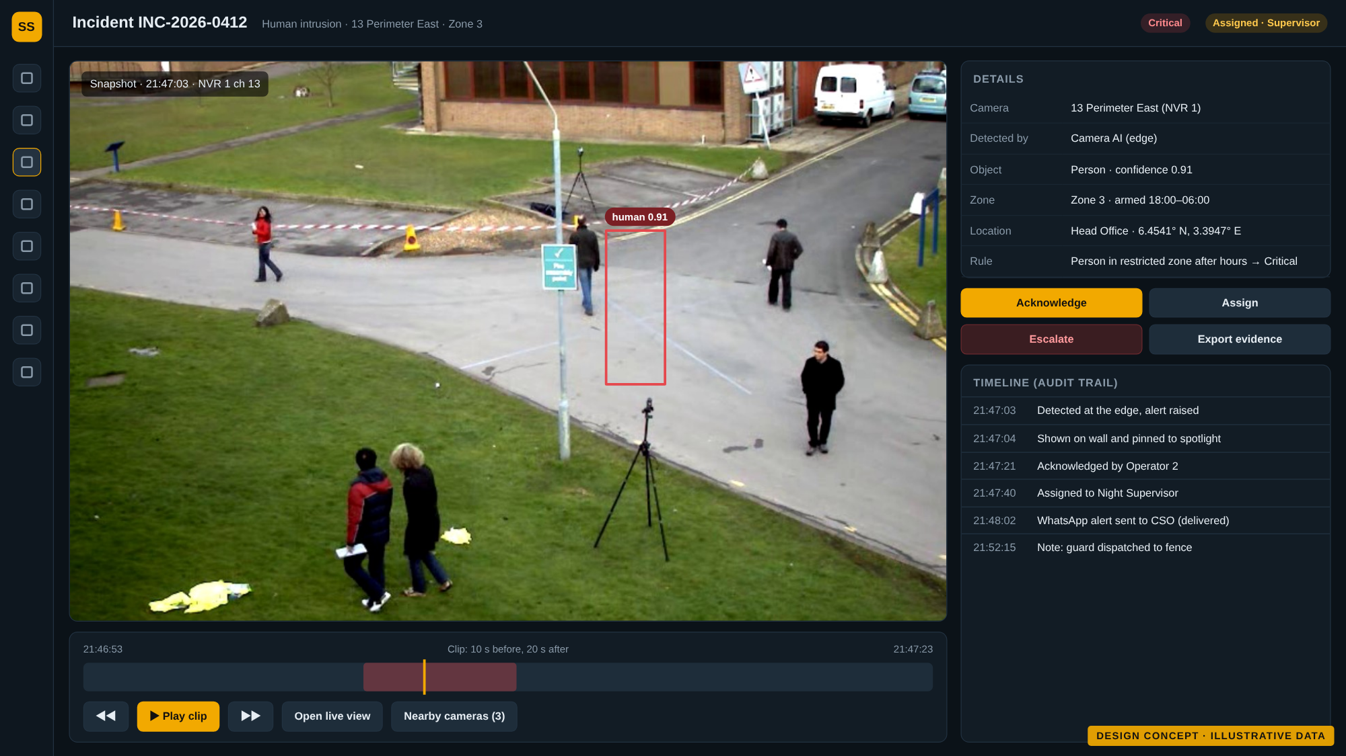
Figure 4. Incident record with snapshot, clip and audit trail. Design concept with illustrative data; not yet built.

5. Smart detection

5.1 Edge first, server assisted
The platform uses the AI already inside your cameras and NVRs wherever it exists, and adds its own server AI only where it is missing. Each camera is placed in one of three tiers automatically; an administrator can change it.
Tier | Cameras | Where analysis runs | Typical alerts
Camera AI | AcuSense cameras | On the camera; lowest cost and fastest | Line crossing, intrusion, loitering, tamper
NVR AI | Non-AI cameras on AI-capable NVRs | On the NVR, for a limited number of channels | Perimeter and motion with person and vehicle filter
Server AI | Remaining non-AI cameras | Open-source AI on NVIDIA GPUs, about 5 frames per second per camera | People and vehicles in zones, by schedule

All three tiers produce the same alerts, rules and reports. Every camera also receives image checks whatever its tier: video loss, frozen image, blocked or dirty lens, and too dark at night. For ColorVu and infrared cameras, the platform can read and schedule the night lighting mode.

5.2 Analytics coverage
A coverage view shows where detection runs for every camera and how busy the server AI is. Critical cameras that rely on server AI are flagged as candidates for replacement with AI models, so that upgrade spending goes where it matters. Server sizing assumes about 60 cameras per GPU at 5 frames per second and is confirmed by benchmark before purchase.
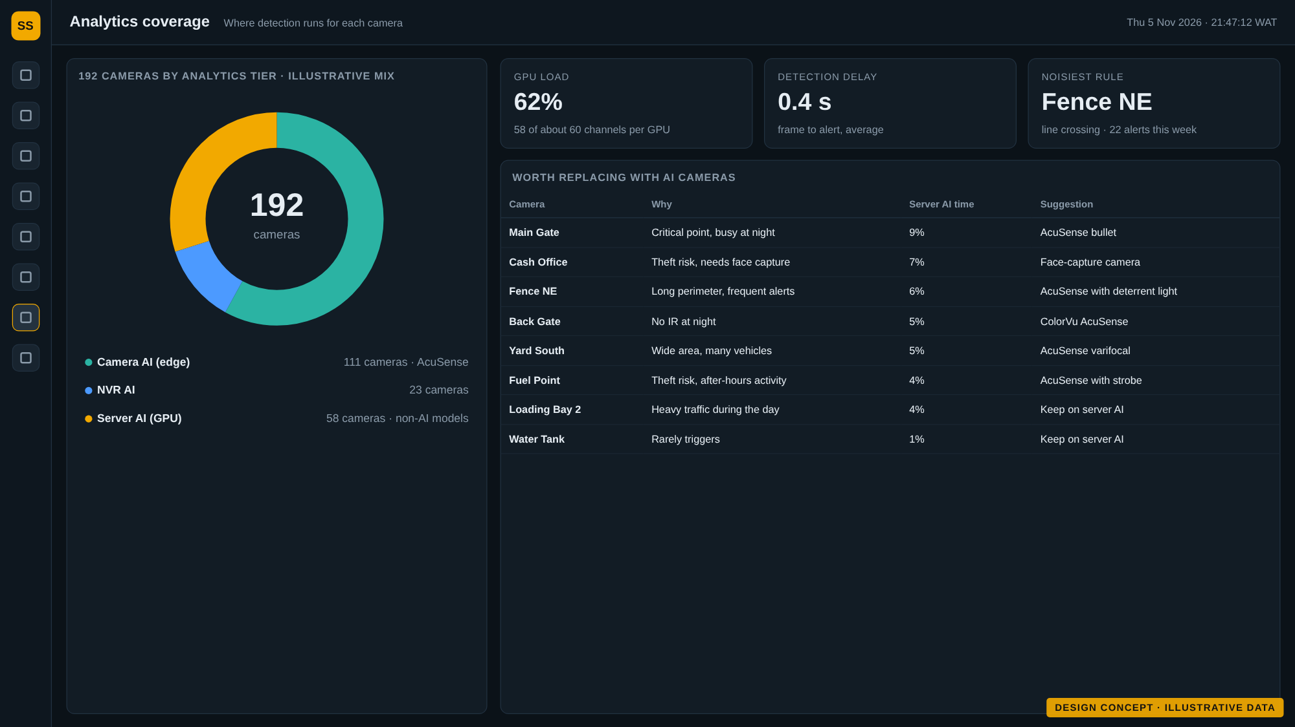
Figure 5. Analytics coverage view. Design concept with illustrative data; not yet built.

5.3 Recording and device health
Video stays on the NVRs for 30 days. The platform checks every morning that each NVR really holds the expected days, and flags recording gaps, drive warnings, high temperatures and clock drift before retention is at risk.
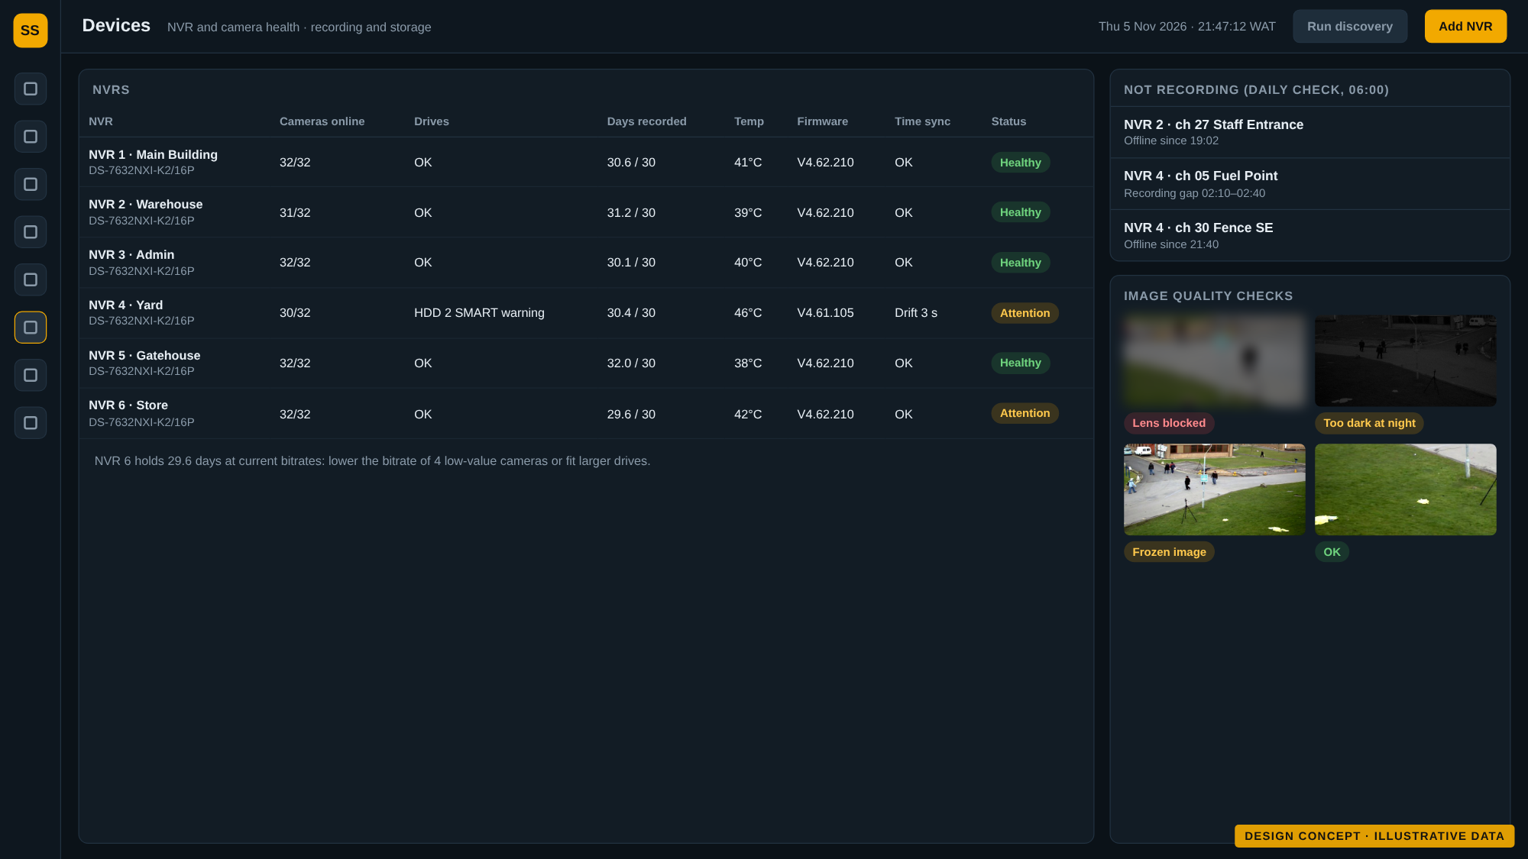
Figure 6. Device and recording health. Design concept with illustrative data; not yet built.

6. Location awareness

6.1 Geofencing and geotagging on the site map
Zones are drawn once on the site map or camera view. Where a camera supports it, the zone is pushed to the camera so detection happens at the edge; otherwise the server AI applies it. Zones can be armed on a schedule (for example 18:00 to 06:00) or around the clock. Every camera has a position and viewing direction, and every event, snapshot and clip inherits its location. Maps use OpenStreetMap data hosted on your server, with your floor plans as uploaded images.
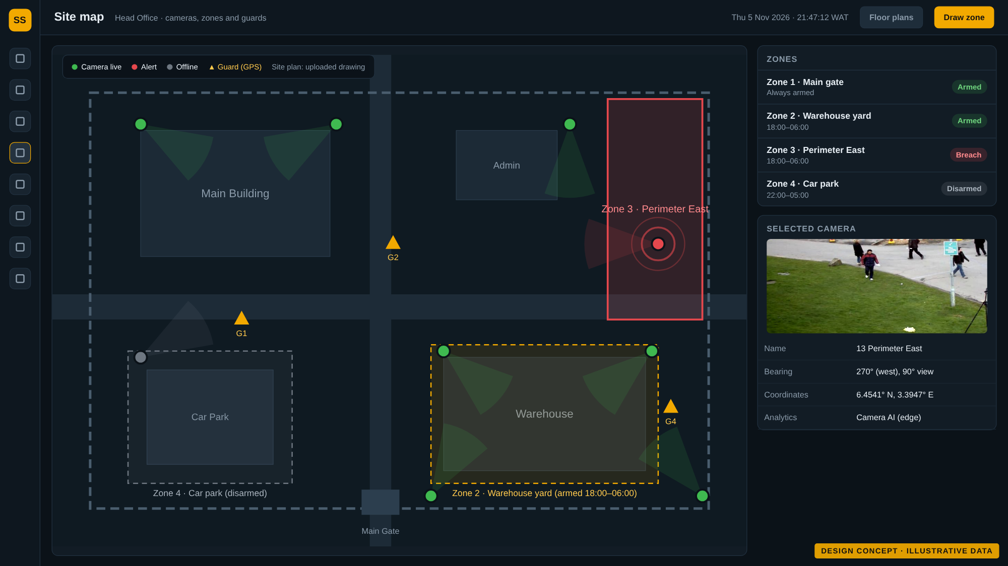
Figure 7. Site map with zones, cameras and guards. Design concept with illustrative data; not yet built.

6.2 Guards and vehicles
Guard phones (starting with 10 Android phones) and vehicle trackers report positions to Traccar, an open-source GPS server. Trackers will be chosen among models with open protocols, so no vendor cloud is needed. GPS zones and camera zones share one rule engine: a vehicle moving after hours, a guard leaving an area or a missed patrol checkpoint raises the same kind of alert.
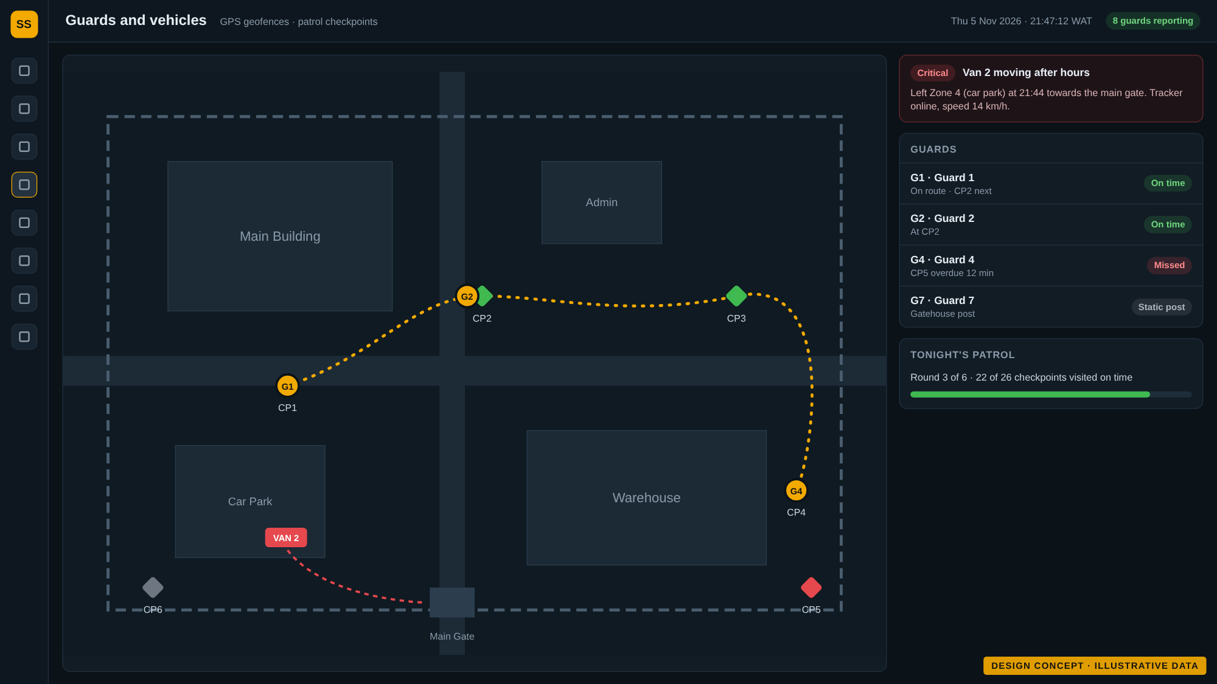
Figure 8. Guards, patrol checkpoints and vehicles. Design concept with illustrative data; not yet built.

7. Face and plate recognition, with safeguards
Recognition is the most sensitive feature and is delivered as a controlled module with its own approval gate.
- Watchlists only: matches against enrolled lists (staff, visitors, blocked persons, allowed and blocked plates). There is no open-ended identification of everyone.
- A person decides: a match is a lead, not proof. An operator confirms it, and every review is logged.
- Camera by camera: recognition runs where a camera sees faces or plates clearly enough, which is tested per camera on your own footage, day and night.
- Open models only: face and plate models with licences that allow commercial use, tuned on local plate formats.
- Legal gate first: under the Nigeria Data Protection Act 2023, biometric data is sensitive personal data. Before go-live: legal review, a data protection impact assessment, a lawful basis, signage, access and retention limits, and your written sign-off. This review can take longer than the software, so we propose to start it now.
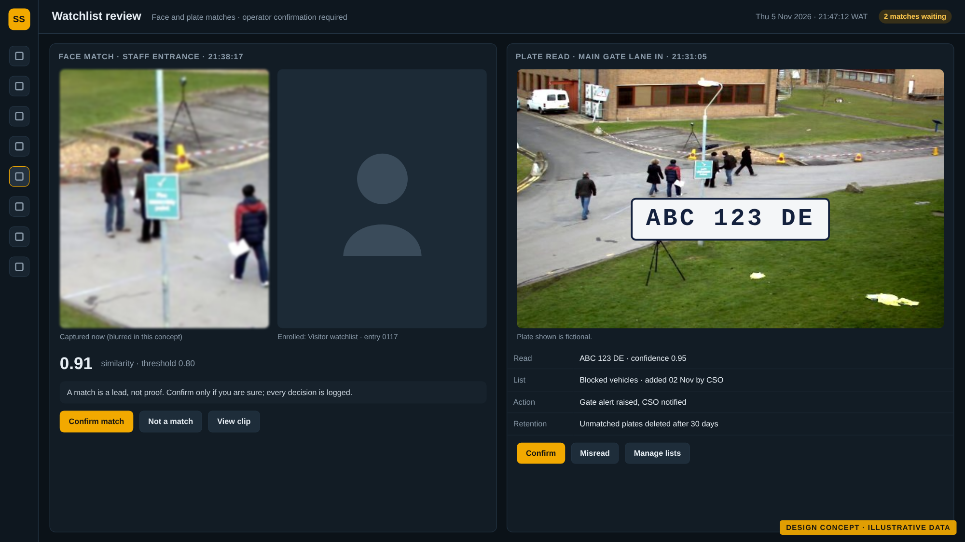
Figure 9. Watchlist review of a face match and a plate read. Design concept with illustrative data; not yet built.

8. Reports and notifications

8.1 Automated reports
Reports combine a plain-language summary with charts and tables, in both Word and PDF, with your logo and colours. They are generated on a schedule or on demand for any period, site or camera, and archived in the platform.
Report | Contents
Daily | Event totals by type, critical incidents with snapshots, camera and NVR health and downtime, zone breaches, open items
Weekly | Trends against the previous week, top places and times, repeat alerts, device uptime, action items
Monthly | Executive summary, charts, month-on-month comparison, incident register, device and storage trends, recommendations

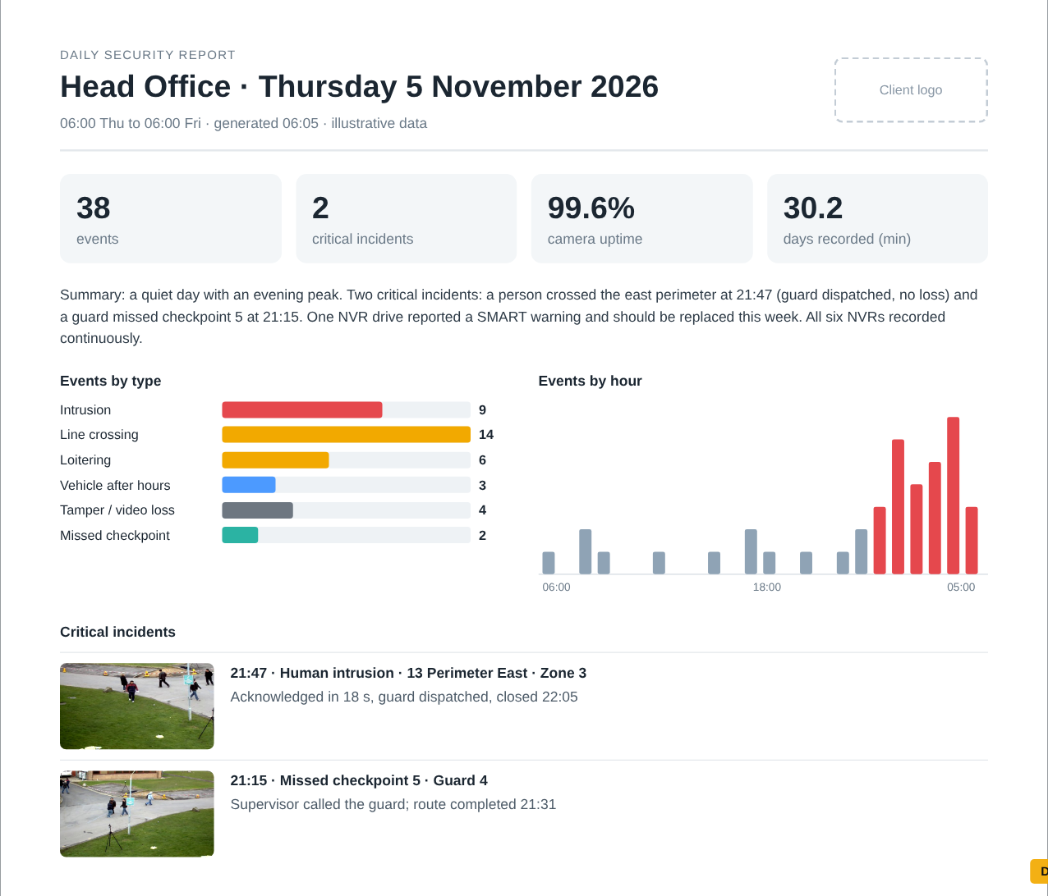
Figure 10. Daily report page. Design concept with illustrative data; not yet built.

8.2 Delivery by WhatsApp, with fallback
Reports and critical alerts are sent from a dedicated WhatsApp number through a self-hosted gateway, kept to low volume. If WhatsApp is unavailable, the same message goes by email automatically, and alerts also reach a self-hosted push app. Delivery is tracked, and subscriptions are set per recipient, with opt-in records.
Recipient | Receives
Management | Weekly and monthly executive PDF
CSO | Daily report and critical alerts
IT Manager | Daily report, device health and system alerts

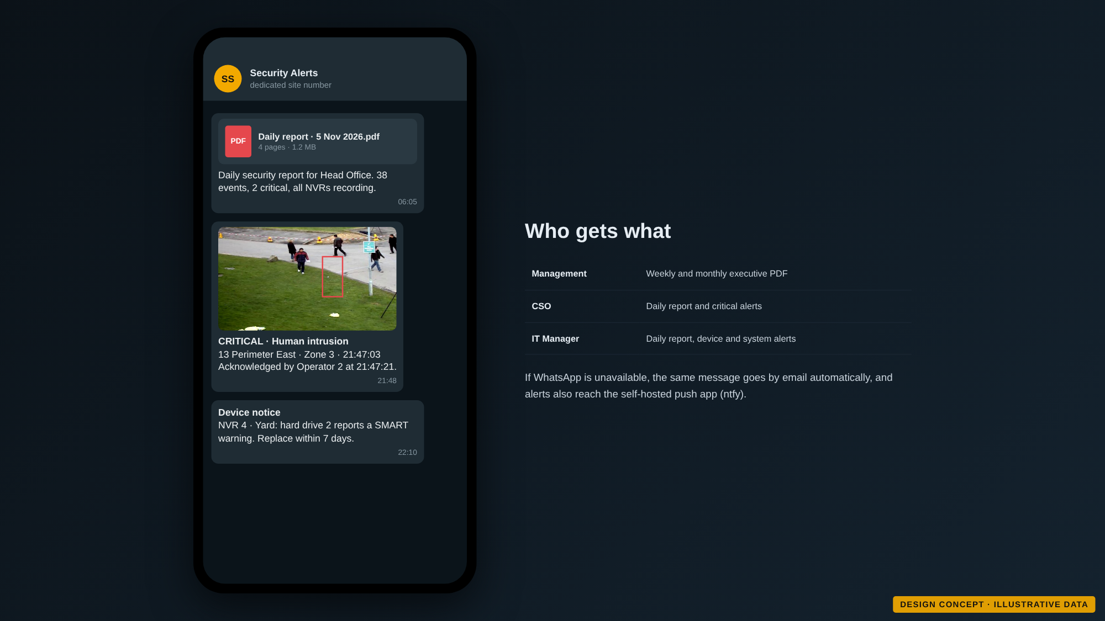
Figure 11. Reports and alerts on WhatsApp. Design concept with illustrative data; not yet built.

9. Wall PCs that look after themselves
A small agent on each wall PC opens the assigned screens in kiosk mode on each TV, restarts any screen that crashes or freezes, brings the wall back after a power cut, reports health to the platform and updates itself. What each TV shows is chosen centrally. The agent installs with one installer, silently if needed, on Windows or Linux wall PCs.
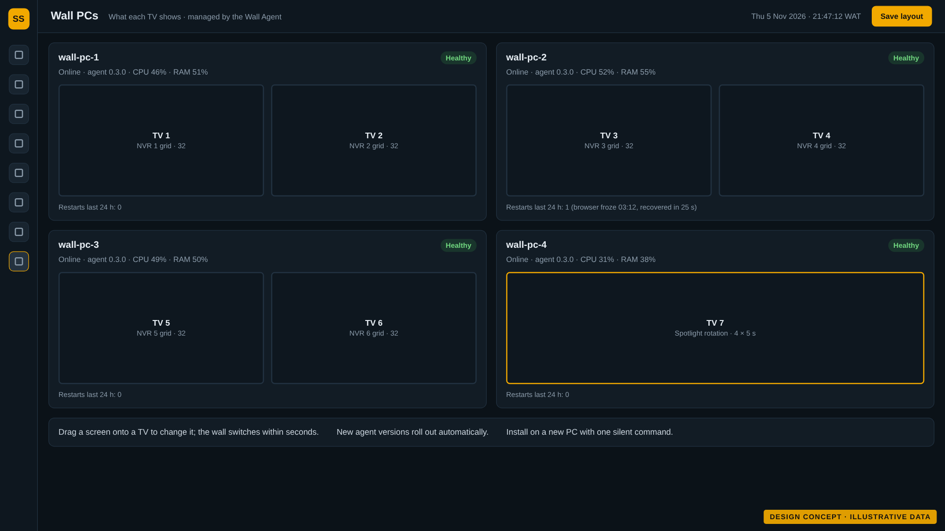
Figure 12. Wall PCs and what each TV shows. Design concept with illustrative data; not yet built.

10. How it fits together
The platform talks to your devices directly, without HikCentral or Hik-Connect, and runs on a Linux server on your premises (a hosted option with a small site connector is also planned). Video stays on the NVRs; the platform keeps events, evidence clips and reports.
Your devices | Platform | People and outputs
Hikvision NVRs (6 to 20) | Device connection: ISAPI, ONVIF, RTSP | Video wall and spotlight
AcuSense and ColorVu cameras | Stream gateway: each camera pulled once | Operator web and mobile
Non-AI cameras | Events, rules, incidents and evidence | WhatsApp, email and push
GPS phones and trackers | Server AI workers on NVIDIA GPUs | Word and PDF reports
Alarm inputs and sirens | Reports, notifications, users and audit | API for other systems

11. Security, privacy and compliance
- Role-based access: admin, supervisor, operator, viewer and client read-only, per site and per camera.
- Two-factor sign-in, strong passwords and session timeouts.
- Full audit trail of who viewed, exported, changed or deleted what, and when.
- Privacy masking and restricted camera lists.
- Encrypted and separated: encrypted connections and stored device passwords, cameras on an isolated network, no cameras exposed to the internet, default passwords changed at onboarding.
- Retention you control: 30 days of video, longer for evidence, with retention and privacy reports. Signage and retention policies are part of the deliverable.

12. Open technology, no licence lock-in
The platform uses free and open-source software throughout, works with the Hikvision devices you already own, and depends on no single vendor's platform. Declared exceptions: your Hikvision devices, WhatsApp itself, NVIDIA drivers (free to use), and Windows that comes with the wall PCs. Hardware is bought as usual.
Instead of | We use
HikCentral and Hik-Connect | Direct device connections (ISAPI, ONVIF, RTSP)
Paid map services | OpenStreetMap maps hosted on site
SMS gateways | Email and self-hosted push notifications
Paid or non-commercial AI models | Open models: YOLOX, OpenCV face models, PaddleOCR
Licensed server software | Linux server with Docker or Podman

13. Scale and sizing
The design target is 20 NVRs and 640 cameras across several sites without redesign: 7 wall screens today and up to 21 later, a target of under 3 seconds from detection to alert on screen, and 99.5% platform availability. The sizing below is indicative and is confirmed by benchmark on your cameras before purchase.
 | 6 NVRs · 192 cameras | 10 NVRs · 320 cameras | 20 NVRs · 640 cameras
Layout | One server | One server, second GPU as needed | Core node, 2 to 3 AI nodes, database node
CPU | 12 to 16 cores | 24 to 32 cores | 16 to 24 cores per node
Memory | 64 GB (ECC preferred) | 128 GB | 64 to 128 GB per node
GPU | 1 × NVIDIA 16 GB class | 1 to 2 × NVIDIA 16 to 24 GB class | 1 GPU per AI node
System disks | 2 × 1 TB NVMe, mirrored | 2 × 2 TB NVMe, mirrored | 2 × 2 TB NVMe, mirrored
Evidence storage | 8 TB usable | 16 TB usable | 32 TB or more usable
Network | 1 GbE minimum, 10 GbE recommended | 10 GbE | 10 GbE, 25 GbE core
Wall PCs | 4 PCs for 7 screens | 6 PCs for 11 screens | 11 PCs for 21 screens

NVR storage for 30 days depends on each camera's bitrate (1 Mbps for one day is about 10.8 GB). The drive set-up for each NVR model is agreed after the discovery scan measures real bitrates.
Camera profile | Per camera, 30 days | Per 32-camera NVR | With 15% headroom
2 MP at 2 Mbps | 648 GB | 20.7 TB | 23.8 TB
4 MP at 3 Mbps | 972 GB | 31.1 TB | 35.8 TB
4 MP at 4 Mbps | 1.3 TB | 41.5 TB | 47.7 TB
8 MP at 6 Mbps | 1.9 TB | 62.2 TB | 71.5 TB

14. Roadmap
Delivery is staged, each stage ending with a review point with you. Dates will be agreed after discovery.
Stage | Contents | Gate
Discovery and proof of concept | Inventory of every NVR and camera, tests on your real devices, wall PC and AI benchmarks | Go or no-go, requirements sign-off
Release 1.0 · Must have | Video wall and spotlight, alerts and incidents, maps and zones, AI for non-AI cameras, reports by WhatsApp, security and backups | First client pilot and acceptance
Release 1.1 · Should have | Face and plate recognition (after the legal gate), GPS guards and vehicles, evidence vault, PTZ, smart search, onboarding wizard | Accuracy results and legal sign-off
Release 2.0 · Could have | Anomaly detection, cross-camera tracking, heat maps, access control integration, mobile app, more languages | Prioritised with you

15. What we need from you
Topic | Decision or input
NVR storage | Agree the drive set-up that keeps 30 days on every NVR
Recognition scope | Which entrances and cameras should run face and plate recognition
WhatsApp | A dedicated number, recipient numbers and preferred send times
Legal review | A lawyer or data protection officer for the biometric review
Wall hardware | Confirm wall PCs and TVs, and whether a fourth wall PC is needed
Branding | Logo, colours and report language
Hosting | On-premises only, or also a hosted option, and the provider

16. Next steps
- Review this concept: tell us what to change, add or drop.
- Start the long-lead items: WhatsApp number, legal review, hardware details.
- Run discovery on site: scan every NVR and camera, then agree the release 1.0 plan.

Appendix: technology stack
Layer | Components | Licence
Server | Debian or Ubuntu Server LTS, Docker Engine or Podman | Free software, Apache 2.0
Database | PostgreSQL with PostGIS | PostgreSQL, GPL (separate service)
Backend | Python, FastAPI | PSF, MIT
Video | MediaMTX or go2rtc, FFmpeg (LGPL build) | MIT, LGPL
AI | ONNX Runtime with TensorRT on NVIDIA (OpenVINO on Intel), YOLOX or RT-DETR | MIT, Apache 2.0; NVIDIA free to use
Recognition | OpenCV YuNet and SFace, PaddleOCR | MIT, Apache 2.0
GPS and maps | Traccar, Leaflet or MapLibre, OpenStreetMap tiles hosted on site | Apache 2.0, BSD, ODbL data
Reports and alerts | WeasyPrint, python-docx, email, ntfy, WhatsApp gateway | BSD, MIT, Apache 2.0
Wall PCs | Wall Agent with Windows installer (NSIS), Chromium kiosk | Our code, zlib, BSD-style

